Appendix: Communication plan

This communication plan template is a tool to plan your communication strategy to firstly raise awareness for the need of high quality newborn healthcare and secondly drive forth the implementation of high quality health standards in your country. The references are the European Standards of Care for Newborn Health and the Call to Action for Newborn Health in Europe. Please note that this is an example to give you some possible ideas and that you have to tailor the content according to your organisation’s needs. The content also varies from year to year, depending on the events and activities taking place. As it is a working document for your organisation, make sure to update it on a monthly and annual basis.

In chapter Communication: Campaigning, we provide ready-to-use messages for the online and social media content suggested in this communication plan. As indicated in the template, we also recommend you to structure your communication corresponding to the monthly topics of the campaign 11 Months – 11 topics (running from February until December; see chapter Communication: Campaigning, but you can also choose your own focus topics.

Besides the examples given in this toolkit, there are many other possibilities to promote the standards – unleash your imagination!

If you have any questions regarding the use of the copyright guidelines, do not hesitate to contact us via standards@efcni.org.

Do not forget to share your information with EFCNI in advance of the publication via standards@efcni.org as we can support you in promoting your content.

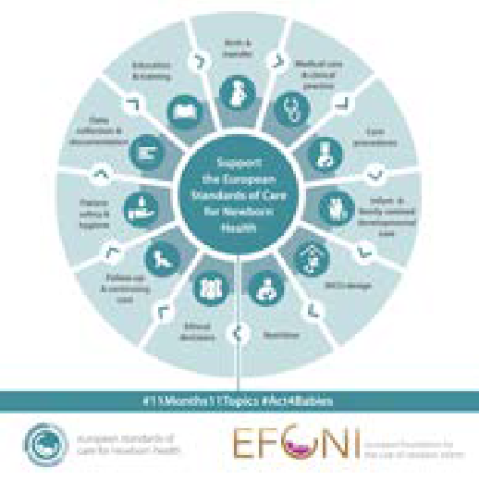
Month | Examples for possible content/activities | Using the following channels
January
 | - Announcement of the campaign 11 Months – 11 Topics: you can use the social media graphic (see chapter Communication: Social media  - News article on a presentation about the standards (e.g. at EFCNI’s Parent Organisations Summit, congress/conference in your country)  - If you are a supporter of the standards, show your commitment on your website by linking to www.newborn-health-standards.org/partners | - Website  - Social media: e.g. Facebook, Twitter, Instagram, LinkedIn, etc.  - Newsletter  - Website  - Newsletter  - Social media  - Website

Communication: Social media)
Month | Examples for possible content/activities | Using the following channels
February | Data collection & documentation
 | - Report about you/your organisation’s participation in a workshop by EFCNI on the implementation of the European Standards of Care for Newborn Health (if applicable, in practice, the exact timing of the event may vary)*  - Share the video of the Chairs of the Topic Expert Group who developed the standards on Data collection and documentation (available on the EFCNIwecare YouTube channel)**  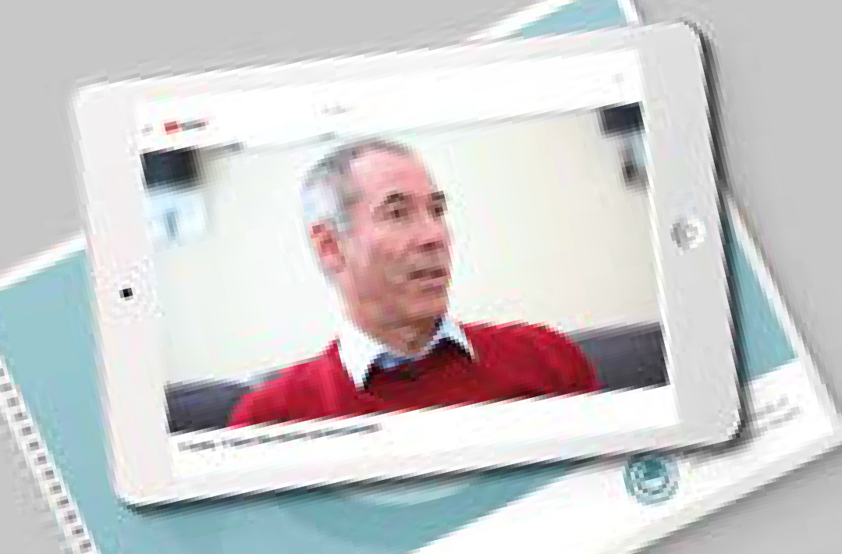  - Share research news about Data collection and documentation, e.g. about the EU-funded project RECAP preterm (Research on European Children and Adults born Preterm); view more at www.efcni.org/recap | - News section on your website  - Newsletter  - YouTube  - Facebook  - Twitter  - Website  - LinkedIn
March | Birth & transfer
 | - Provide information materials on Birth and transfer (e.g. new content on your website, a new information booklet etc.)  - Present the standards in the field of Birth and transfer,  e.g. by focusing on one selected standard ‘in brief’ like the standard on ‘Maternal transfer for specialist care’)**  - Organise an expert meeting in the field of Birth and transfer (or about the standards in general): (see chapter How to get started and communicate the outcome of the event to your local media | - Printed booklet or flyer  - Website content  - Website  - Social media  - Expert meeting, e.g. at  your office at a local hospital or at a local hospital  - Media release  - Website  - Newsletter

Month | Examples for possible content/activities | Using the following channels
April | Follow-up & continuing care
 | - If applicable*: Give a talk about the standards (e.g. at a conference by a national healthcare society or at national parliament) and report about it  - Promote the standards on follow-up & continuing care, e.g. the standard on ‘Respiratory outcome’**  - Focus on the importance of follow-up, e.g. by promoting the toolkit of the EU-funded project Screening to improve Health In very Preterm InfantS in Europe (SHIPS); view more at www.efcni.org/ships | - Presentation  - Website  - Newsletter  - Social media  - Social media  - Project website www.newborn-health- standards.org  - Newsletter  - Website  - Social media
May | NICU design
 | - Start a social media campaign on the occasion of Parents of Preemies Day: ask your social media followers to share their stories on what helped most during their time in the NICU  - Provide an overview of the standards in the field of NICU design (e.g. link to the full set of standards or share the overview of the statements of the standards in NICU design)**  - Organise a press conference on the occasion of International Nurses Day: invite local experts, especially nurses, who work in line with the standards and motivate others to follow their example | - Social media  - Social Media  - Press conference  - Media release  - Social Media (e.g. Instagram / create an Instagram Story to report live about the event)
June | Medical care & clinical practice
 | - Publish an interview with an expert in the field of Medical care and clinical practice, e.g. on health conditions of babies are treated for in the NICU, e.g. Respiratory Syncytial Virus (RSV), jaundice, bronchopulmonary dysplasia (BPD), or Retinopathy of Prematurity (ROP)  - Support the Call to Action for Newborn Health in Europe: share a photo/video of you or a key stakeholder in your country together with the Call to Action statement on Medical care and clinical practice (available at https://newborn-health-standards.org/downloads)  - Write an article for a scientific journal and ask a key opinion leader in your country to give a statement on the need for the implementation of the standards in your country | - Website  - Newsletter  - Social media  - Poster (print)  - Social media (esp. Facebook, Instagram, Youtube)  - Article in scientific journal or comment in daily newspaper

Month | Examples for possible content/activities | Using the following channels
July | Ethical decision-making & palliative care
 | - Promote projects in the field of Ethical decision-making and palliative care, e.g. the project PaluTiN on Palliative Care and Grief Counseling in Perinatology and Neonatology by the German Association Das frühgeborene Kind e.V. (available at http://bit.ly/Bundesverband_PaluTiN)  - Provide information for parents about ethical decision-making and palliative care on your website and promote the new content  - Promote the information brochure about the European Standards of Care for Newborn Health (download at www.newborn-health-standards.org/downloads) | - Booklet  - Website  - Social media  - Channels of your cooperation partners  - Website  - Newsletter  - Website  - Social media
August | Nutrition
 | - Newspaper/radio/TV interview with you/the chairperson of your organisation on the occasion of World Breastfeeding Week: e.g. explain the work of your organisation, the standards in the field of nutrition related to breastfeeding; make sure to provide reliable evidence (e.g. on breastfeeding rates)  - 17 August: Share collage of pictures of last year’s World Prematurity Day together with a share a countdown message e.g. ‘… only 3 months left until World Prematurity Day on 17 November…’ and announce the annual global WPD motto (available at www.efcni.org/worldprematurityday)  - Share a link to the standards in the field of nutrition together with an article by a healthcare expert in the field (e.g. on human milk banks or parenteral nutrition) | - Newspaper  - Radio  - TV  - Social media  - Social media (esp. Instagram, Facebook)  - Website  - Social media
September | Education & training of the multidisciplinary team working in neonatology
 | - Feature an example of an inspiring project in the field of education and training; for ideas go to www.efcni.org and search for ‘lighthouse project’  - Autumn is congress season: If you/your organisation is participating in a national congress in your country or an international conference or congress, e.g. the Congress of joint European Neonatal Societies (jENS), share a photo of you at the congress/of a presentation/your booth etc.  - Start a charity activity in preparation of World Prematurity Day: e.g. a tombola to raise funds for a training in a local hospital based on the standards  - Disseminate this toolkit, e.g. share the digital version (available at www.newborn-health-standards.org/downloads) on social media, within your community or send out printed copies to selected KOLs | - Social media  - Website  - Newsletter  - Congress  - Website  - Social media  - Website  - Social media (e.g. Facebook ‘Fundraising & Charitable Giving’ tool)  - Mailing(s): e.g. postal mailing  - Newsletter  - Social media

Month | Examples for possible content/activities | Using the following channels
October | Patient safety & hygiene practice
 | - In many regions, the RSV (respiratory syncytial virus) season starts in autumn; thus Healthy Lung Month, Global Handwashing Day, and Lung Health Day are good opportunities to raise awareness for the importance of (hand-) hygiene to prevent respiratory infections like RSV: | - Socia media  - Website  - Newsletter
 | - Link to EFCNI’s campaign Wash your hands – it’s easy (target group: parents/families)
 | - Promote the standard on ‘hand hygiene’ (target group: healthcare professionals)
 | - Promote the Call to Action for Newborn Health in Europe: focus on the statement on Patient safety & hygiene practice (free download of the graphic at: www.newborn- health-standards.org/downloads)** | - Social media
November | Infant & family-centred developmental care
 | - Use 17 November - World Prematurity Day (WPD) as a key momentum to communicate about the standards, e.g.  - Share photos of events around the world related to the standards  - Promote your own WPD events with regard to the standards (e.g. a roundtable with experts)  - Share information and pictures about your event with EFCNI via worldprematurityday@efcni.org to make it visible on the global website www.efcni.org/ worldprematurityday  - Include your event in the EFCNI Changemaker Map at  www.efcni.org/changemakermap  - Print a WPD poster and distribute it to your local hospitals (free templates at www.efcni.org/ worldprematurityday)  - Share an overview of the standards in the field of Infant- and family-centred developmental care*  - Give a TV/radio/newspaper interview or publish an article in a scientific journal in your country: Explain the standards and how they could affect the change in your country | - Social Media  - Website  - EFCNI Changemaker Map  - Newsletter  - Live event  - Social media  (especially LinkedIn, Twitter)  - Media (TV/radio/newspaper)  - Scientific journal

Month | Examples for possible content/activities | Using the following channels
December | Care procedures
 | - Look for inspiring projects/activities by your partners in the field of care procedures and publish an article or an interview  - The holiday season traditionally is a good momentum to thank your network, corporate partners, collaboration partners, donors, and staff for their commitment for the implementation of the standards: Create, for example, special (digital or printed) thank you/seasonal cards and share a review of what you have achieved in your country with regard to the standards, as well as an outlook of your plans for the upcoming year | - Website  - Newsletter  - Greeting card (print/online)  - Digital mailing
Outlook
 | - Document and evaluate your efforts: Report the annual outcome of your activities to your project and corporate partners etc. and think about what has gone well and what could be improved for the next year  - Be prepared for the upcoming year: Start developing the annual communication plan for the next year, schedule your events and congress participations, hold an annual strategy meeting with your team to align on milestones for the upcoming year, etc. | - Internal activity

* The timing of this content may differ and take place in another month. Depending on the date of the meeting/ event, it may make sense to communicate about it at a later stage.

** Recurring content which can be repeated every month; for more information, please have a look at the campaign website www.efcni.org/11-months-11-topics and EFCNI’s social media channel.

